Agenda

*Date: 05/25/13*

*Location: Calit 2*

*Actual Time: 12:30pm - ?*

*Planned Length: ?*

***Silly Picture of the Week:***

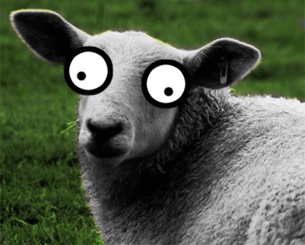

***Please add and comment on anything and everything in the agenda!***

|  |  |  |  |
| --- | --- | --- | --- |
| Team Member(s) | Topic | Time | Goals |
| ~~Sorin~~ | ~~Announcements~~ | ~~5 min~~ | ~~All team members are updated on new developments~~ |
| ~~David~~ | ~~Continuity Report~~ | ~~15 min~~ | ~~Continuity report responsibilities are reviewed and assigned.~~ |
| Frontend | Work on creating the next frame |  | Try to implement the current Eye Detection software into the GUI /  learn about Model View Controller /  think of ways to get to the next frame |
| Backend/Frontend | Integration with UI | Remainder of time | Work on integrating existing controller code with existing UI; establish actions and returns for Controller code; implement these as much as possible |
| ~~Backend: JT and Shannon~~ | ~~Fix eyeRemove code~~ | ~~Remainder of time~~ | ~~Understand regions passed into various rectangle functions and fix code to populate eyePhoto properly~~ |
| Backend: : Brian, David, JT | Pupil detection | Remainder of time | Develop a working draft of pupil detection |
| ~~Backend: Kevin and Sorin~~ | ~~Eye detection~~ | ~~Remainder of time~~ | ~~Review eye detection code and modify it to fix overdection of non-eye regions~~ |
| ~~Backend: Paul~~ | ~~Documentation~~ | ~~Remainder of time~~ | ~~Continue to develop documentation/troubleshoot mac installation~~ |
| Backend | Next week’s tasks | 10 min | Set goals for next week; assign tasks; update scrumy |
| ~~Sorin~~ | ~~Recap and Next steps~~ | ~~5 min.~~ | ~~Meeting progress/ goal accomplishment is recapped. Next steps are outlined so that every team member goes into next week knowing what they are expected to contribute~~ |

**Time total:** ?

# Notes

Backend

Pupil detection was drafted, currently has runtime errors

Eye detection was tweaked to fix over detection. Success rate for eye detection after today’s fixes is 54%. I’m not sure which photos count as representative though.

Code was given to frontend team to interact with the controller

# Summary

See continuity report for assignments of continuity report sections

# TODO

# Backend has not yet decided on tasks for next week

* Do your section of the continuity report

# Whiteboard Pics

Please post the pic of the Controller to UI code